Selenium WebDriver – Disposable Selenium Grid Infrastructure Setup using Zalenium
May 29, 2017 1 comment Article

Overview:
We already have seen the challenges related to setting up the Selenium Grid infrastructure and how docker helps us in setting up a flexible/disposable/highly scalable selenium grid within few seconds in these articles below.
- Docker – Selenium Grid Setup
- Arquillian Cube – Managing Dockerized Selenium Grid
./Selenium WebDriver – Managing Selenium Grid Infrastructure using Arquillian Cube.odt
In this article, We will see how Zalenium (a similar dockerized selenium grid infrastructure with few other features) helps.

Zalenium Setup:
- Ensure that you have latest docker engine is running. You can get the instructions here on installing docker.
- Pull below docker images.
  - docker pull elgalu/selenium
  - docker pull dosel/zalenium
- Run the below command to start the zaleniukm-selenium-grid
docker run --rm -ti --name zalenium -p 4444:4444 -p 5555:5555 \
-v /var/run/docker.sock:/var/run/docker.sock \
-v /tmp/videos:/home/seluser/videos \
dosel/zalenium start
Copy
- Zalenium is ready to use now in our tests.
DesiredCapabilities dc = DesiredCapabilities.firefox();
RemoteWebDriver driver=new RemoteWebDriver(new URL("http://10.11.12.13:4444/wd/hub"), dc);

driver.get("https://www.google.com");
Copy

Zalenium – Live Preview:
- One of the cool features of zalenium is the live preview of the dockerized containers. We can access this using below URL.
  - http://ipofdockerenginer:4444/grid/admin/live#
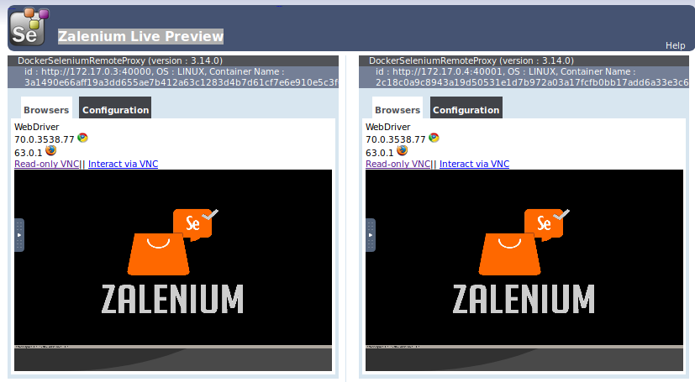
- By default, our Selenium grid will have 1 Chrome and 1 Firefox container. If you need more, say 3 chrome containers, 2 firefox then use below arguments
  - –chromeContainers 3

  - –firefoxContainers 2
docker run --rm -ti --name zalenium -p 4444:4444 -p 5555:5555 \
-v /var/run/docker.sock:/var/run/docker.sock \
-v /tmp/videos:/home/seluser/videos \
dosel/zalenium start --chromeContainers 3 --firefoxContainers 2
Copy

ermao750125@ermao750125-ThinkPad-W520:~/autoguru_app$ docker run --rm -ti --name zalenium -p 4444:4444 -p 5555:5555 \
> -v /var/run/docker.sock:/var/run/docker.sock \
> -v /tmp/videos:/home/seluser/videos \
> dosel/zalenium start
WARNING: Error loading config file: /home/ermao750125/.docker/config.json: stat /home/ermao750125/.docker/config.json: permission denied
Docker version 17.12.1-ce, build 7390fc6
-- LOG 04:38:20:325592335 Ensuring docker works...
-- LOG 04:38:20:380438897 Ensuring no stale Zalenium related containers are still around...
-- LOG 04:38:20:405877021 Ensuring docker-selenium is available...
haveged: haveged starting up
Copying files for Dashboard...
Starting Nginx reverse proxy...
Starting Selenium Hub...
...04:38:21.181 [main] INFO o.o.grid.selenium.GridLauncherV3 - Selenium build info: version: '3.14.0', revision: 'unknown'
.04:38:21.186 [main] INFO o.o.grid.selenium.GridLauncherV3 - Launching Selenium Grid hub on port 4445
.04:38:21.550 [AutoStartProxyPoolPoller] INFO d.z.e.z.proxy.AutoStartProxySet - Starting poller.
04:38:21.550 [AutoStartProxyPoolPoller] INFO d.z.e.z.proxy.AutoStartProxySet - AutoStarting container, because 0 is less than min 2
..04:38:21.981 [main] INFO d.z.ep.zalenium.aspect.HubAspect - Registering custom Zalenium servlets
.04:38:22.070 [main] INFO org.openqa.grid.web.Hub - Selenium Grid hub is up and running
04:38:22.070 [main] INFO org.openqa.grid.web.Hub - Nodes should register to http://172.17.0.2:4445/grid/register/
04:38:22.071 [main] INFO org.openqa.grid.web.Hub - Clients should connect to http://172.17.0.2:4445/wd/hub
Selenium Hub started!
Sauce Labs not enabled...
Browser Stack not enabled...
TestingBot not enabled...
Zalenium is now ready!
*************************************** Data Processing Agreement ***************************************
By using this software you agree that the following non-PII (non personally identifiable information)
data will be collected, processed and used by Zalando SE for the purpose of improving our test
infrastructure tools. Anonymisation with respect of the IP address means that only the first two octets
of the IP address are collected.

See the complete license at https://github.com/zalando/zalenium/blob/master/LICENSE.md
*************************************** Data Processing Agreement ***************************************
04:38:24.199 [AutoStartProxyPoolPoller] INFO d.z.e.z.p.DockeredSeleniumStarter - Created container [zalenium_WFJBoZ] with dimensions [(1920, 1080)] and tz [sun.util.calendar.ZoneInfo[id="Europe/Berlin",offset=3600000,dstSavings=3600000,useDaylight=true,transitions=143,lastRule=java.util.SimpleTimeZone[id=Europe/Berlin,offset=3600000,dstSavings=3600000,useDaylight=true,startYear=0,startMode=2,startMonth=2,startDay=-1,startDayOfWeek=1,startTime=3600000,startTimeMode=2,endMode=2,endMonth=9,endDay=-1,endDayOfWeek=1,endTime=3600000,endTimeMode=2]]].
04:38:24.200 [AutoStartProxyPoolPoller] INFO d.z.e.z.proxy.AutoStartProxySet - Created ContainerCreationStatus [isCreated=true, containerName=zalenium_WFJBoZ, containerId=3a1490e66aff19a3dd655ae7b412a63c1283d4b7d61cf7e6e910e5c3f09b7148, nodePort=40000].
04:38:28.369 [Thread-12] INFO d.z.e.z.registry.ZaleniumRegistry - Registered a node http://172.17.0.3:40000
04:38:34.295 [AutoStartProxyPoolPoller] INFO d.z.e.z.p.DockeredSeleniumStarter - Created container [zalenium_eNce5O] with dimensions [(1920, 1080)] and tz [sun.util.calendar.ZoneInfo[id="Europe/Berlin",offset=3600000,dstSavings=3600000,useDaylight=true,transitions=143,lastRule=java.util.SimpleTimeZone[id=Europe/Berlin,offset=3600000,dstSavings=3600000,useDaylight=true,startYear=0,startMode=2,startMonth=2,startDay=-1,startDayOfWeek=1,startTime=3600000,startTimeMode=2,endMode=2,endMonth=9,endDay=-1,endDayOfWeek=1,endTime=3600000,endTimeMode=2]]].
04:38:34.295 [AutoStartProxyPoolPoller] INFO d.z.e.z.proxy.AutoStartProxySet - Created ContainerCreationStatus [isCreated=true, containerName=zalenium_eNce5O, containerId=2c18c0a9c8943a19d50531e1d7b972a03a17fcfb0bb17add6a33e3c600457cef, nodePort=40001].
04:38:34.295 [Thread-12] INFO d.z.e.z.proxy.AutoStartProxySet - Registered a container 3a1490e66aff19a3dd655ae7b412a63c1283d4b7d61cf7e6e910e5c3f09b7148 http://172.17.0.3:40000.
04:38:34.376 [AutoStartProxyPoolPoller] INFO d.z.e.z.proxy.AutoStartProxySet - Container zalenium_WFJBoZ started after 10176.
04:38:38.972 [Thread-13] INFO d.z.e.z.registry.ZaleniumRegistry - Registered a node http://172.17.0.4:40001
04:38:38.972 [Thread-13] INFO d.z.e.z.proxy.AutoStartProxySet - Registered a container 2c18c0a9c8943a19d50531e1d7b972a03a17fcfb0bb17add6a33e3c600457cef http://172.17.0.4:40001.
04:38:39.563 [AutoStartProxyPoolPoller] INFO d.z.e.z.proxy.AutoStartProxySet - Container zalenium_eNce5O started after 5268.
05:09:58.757 [qtp1117871068-48] WARN o.s.jetty9.server.HttpChannel - /grid/register/
org.openqa.selenium.json.JsonException: Expected to read a START_MAP but instead have: END. Last 0 characters read:
Build info: version: '3.14.0', revision: 'unknown', time: 'unknown'
System info: host: '019948d4665f', ip: '172.17.0.2', os.name: 'Linux', os.arch: 'amd64', os.version: '4.15.0-38-generic', java.version: '1.8.0_181'
Driver info: driver.version: unknown

at org.openqa.selenium.json.JsonInput.expect(JsonInput.java:289)

ermao750125@ermao750125-ThinkPad-W520:~$ docker ps
WARNING: Error loading config file: /home/ermao750125/.docker/config.json: stat /home/ermao750125/.docker/config.json: permission denied
CONTAINER ID IMAGE COMMAND CREATED STATUS PORTS NAMES
2c18c0a9c894 elgalu/selenium:latest "entry.sh" About an hour ago Up About an hour 40001/tcp, 50001/tcp zalenium_eNce5O
3a1490e66aff elgalu/selenium:latest "entry.sh" About an hour ago Up About an hour 40000/tcp, 50000/tcp zalenium_WFJBoZ
019948d4665f dosel/zalenium "entry.sh start" About an hour ago Up About an hour 0.0.0.0:4444->4444/tcp, 0.0.0.0:5555->5555/tcp, 4445/tcp zalenium
ermao750125@ermao750125-ThinkPad-W520:~$

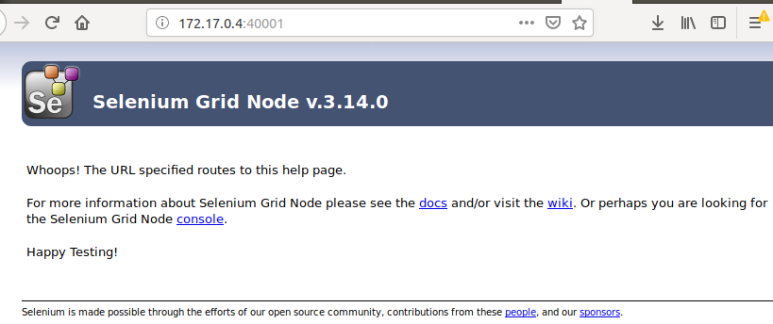
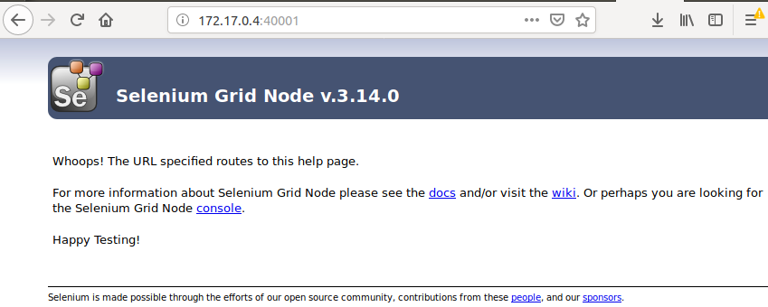
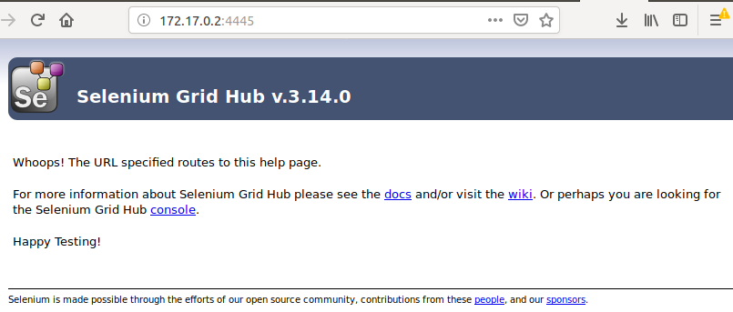
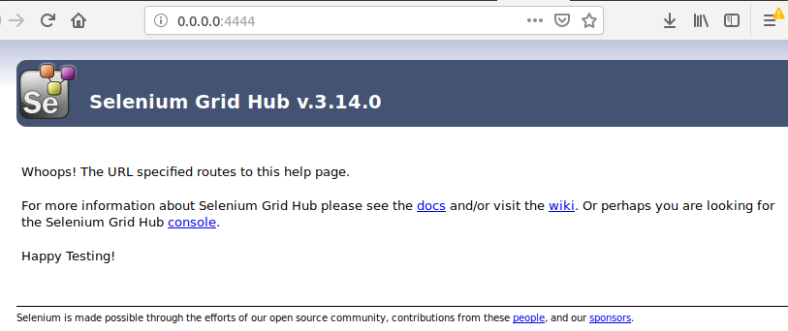

Demo:
I am running the test I had created as part of DatePicker Automation in this demo.

I have embedded this live preview in Jenkins itself. You would like to know how? Check here.
./Selenium WebDriver – Embedding Zalenium Live Preview In Jenkins.odt

Dashboard:
- Zalenium also has a nice dashboard to show the list of recorded tests it has captured.
  - Can be accessed at this URL: http://ipofdockerengine:5555
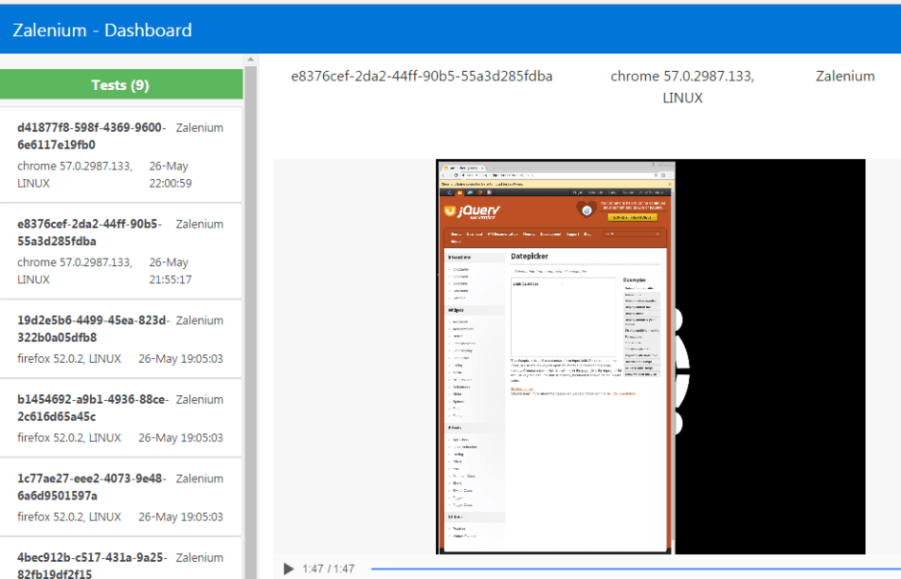
- By default, name of the test has some random string which can be replaced by passing the name of test in the Desired Capabilities.
desiredCapabilities.setCapability("name", "myTestName");
Copy
- Disable the video recording feature using below capability.
desiredCapabilities.setCapability("recordVideo", false);
Copy

Integrating with Cloud Testing Platforms:
- Yet another cool feature of zalenium is – It can be integrated with cloud based testing solutions like BrowserStack/SuaceLabs.
- Any incoming request to the hub is verified by zalenium – If it can create a container for the request, It starts a container and runs the test.
- Otherwise, the test gets executed at the cloud testing platforms.


Sauce Labs:
export SAUCE_USERNAME=[your Sauce Labs username]
export SAUCE_ACCESS_KEY=[your Sauce Labs access key]
docker run --rm -ti --name zalenium -p 4444:4444 -p 5555:5555 \
-e SAUCE_USERNAME -e SAUCE_ACCESS_KEY \
-v /tmp/videos:/home/seluser/videos \
-v /var/run/docker.sock:/var/run/docker.sock \
dosel/zalenium start --sauceLabsEnabled true
Copy

BrowserStack:
export BROWSER_STACK_USER=[your BrowserStack username]
export BROWSER_STACK_KEY=[your BrowserStack access key]
docker run --rm -ti --name zalenium -p 4444:4444 -p 5555:5555 \
-e BROWSER_STACK_USER -e BROWSER_STACK_KEY \
-v /tmp/videos:/home/seluser/videos \
-v /var/run/docker.sock:/var/run/docker.sock \
dosel/zalenium start --browserStackEnabled true
Copy
For more information on Zalenium, please check here.

